**Scaffolding**

**Project**

**User Manual**

Contents Page Num

Introduction 3

A) Basic Interface 3

B) Company: 3

C) Users: 3

a) Super Admin (SA) 3

b) Super User (SU) 3

c) Client Admin (CA) 4

d) Client User(CU) 4

e) Yard Manager (YM) 4

f) Project Manager (PM) 4

D) Projects 4

E) Product: 4

F) Cart: 5

G) Orders 5

a) Sale 5

b) Rent 5

c) Purchase 5

H) Suppliers 6

I) Inventory: 6

Creating 6

A) Company 6

B) User 6

C) Project 7

D) Project 7

E) Order 7

For Sale and Rent : 7

For Purchase: 9

Updating And Deleting 10

Detail Access Table 11

# Introduction

## Basic Interface

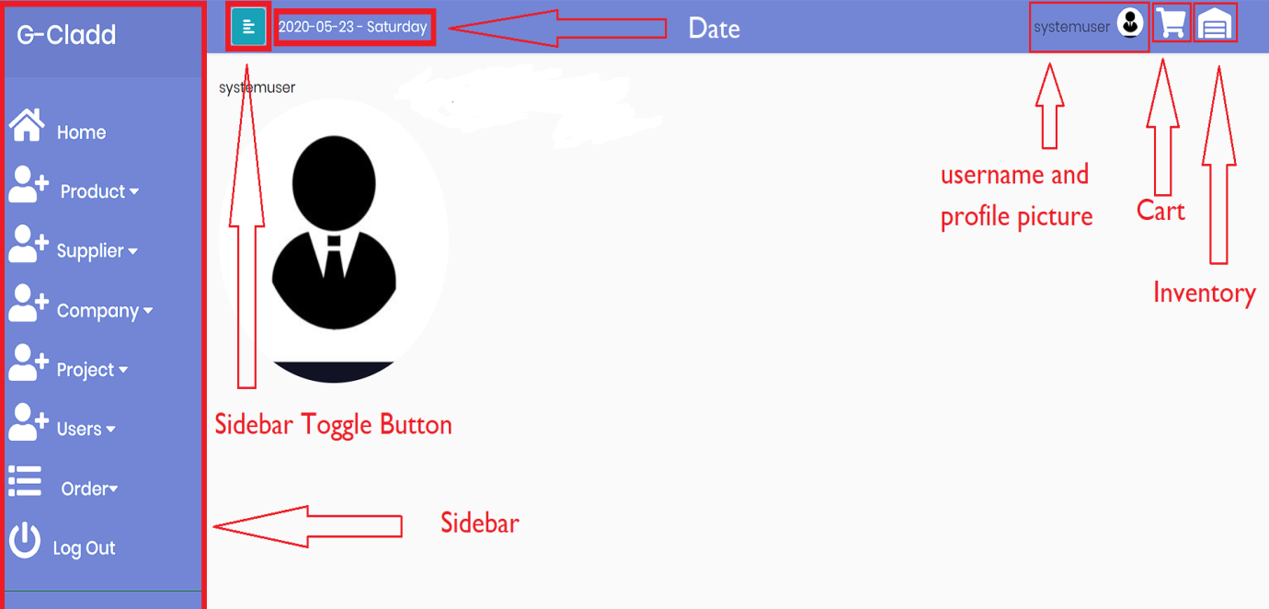

Fig : Home Screen

## Company:

* Stores data about the company
* Two types of company can be registered i.e. “Client” and “Self”
* There can be only one “Self” company

## Users:

* People who can be log in the website
* Each user is associated with one company
* Classified into 6 types having different authority

### Super Admin (SA)

* The user with the highest amount of access
* Associated with company type “Self”
* Only one super admin is possible

### Super User (SU)

* Has almost equal access as of Super Admin
* Employee of the “Self” company
* More than one super user are possible

### Client Admin (CA)

* Head of the client company
* Has access to details of own company details and projects
* Can order quotation and confirm orders
* Only one client admin per Company

### Client User(CU)

* Employee of Client company
* Can view details but cant modify it

### Yard Manager (YM)

* Employee of “Self” company
* Can view the orders that need to be sent to the clients or received from the suppliers
* Can add Delivery Note
* Can add Collection Note to the orders purchased by company

### Project Manager (PM)

* Employee of the “Self” company but is associated with a specific “Client” company
* Can view the projects and order of the company with which it has been associated
* Can add collection Note to the items rented when they are returned

## Projects

* Associated with a company
* Each company can have one or more than one project

## Product:

* Storing the different types of products

## Cart:

* Basic shopping cart for making different types of orders
* Three types : Sale , Rent and Purchase for making respective types of order
* Only one type of cart can be used at a time (eg: if sale cart is not empty , then to use rent or purchase cart, user has to first clear the sale cart)

## **Orders**

* Associated with a single Project
* Three types of order are possible i.e. Sale, Rent, Purchase

### Sale

* Orders Sold by “Self” Company
* Only Delivery Notes can be added to it

### Rent

* Orders Rented by “Self” Company
* Delivery Note can be added by Yard Manager
* Collection Note can be added by Project Manager

### Purchase

* + Orders Purchased by “Self” Company form the suppliers
  + Collection Note can be added by Yard Manager
* Each is assigned a status. Those status are :
* ORDERED : Quotation made by Client
* APPROVED : Discount amount and Advance payment amount assigned
* CONFIRMED : Quotation confirmed by client after reviewing the discount amount and advance payment amount
* PACKING : Advance amount paid by client. Order forwarded to yard manager.
* SHIPPED : Shipped from the yard and Delivery note added
* RETURNED: Only for rental type : Shipped from site :Collection Note added
* PURCHASED : Only for purchase type : Purchase quotation sent to the supplier
* RECEIVED : Only for purchase type : Order received in the yard and collection note added
* CLOSED : Payment cleared

## **Suppliers**

1. For storing the information of the suppliers (Yet)

## Inventory:

1. Viewing the items and their amount in the inventory
2. If viewed by user associated with “Self” Company:

Display the items in the Yard

If viewed by user associated with “Client” Company:

Display the items sold by “Self” company to that “Client” company

**Note:**

* As soon as Delivery note is added in an order , the items of that order is added to the inventory of the client company
* As soon as Collection note is added in rental order, the items of that order is added to the inventory of the Yard

# Creating

## Company

** Prerequisite : System User /Admin Account

** Steps:

1. In sidebar, under Company menu, Select add
2. Add the company details and assign its type
3. Only one company can be assigned “Self” type.

## User

**Prerequisite : System User/Admin Account and at least one Company

**Steps:

1. In sidebar, under the Users menu, select Add
2. Fill in the required details : Assign Company and Account Type

Restrictions:

|  |  |
| --- | --- |
| Company Type | Account Type |
| Self | System Admin, System User, Yard Manager |
| Client | Client Admin, Client User, Project Manager |

* Only one Client admin can be added to a company

* Only one Super admin account can be created

## Project

**Prerequisite: System Admin/User Account and at least one Company

**Steps:

1. In sidebar, under Project menu, select Add
2. Fill in the project details and associate it with a company

**Note**: only one project can be assigned to the “Self” Company

## Project

**Prerequisite: System Admin/User Account

**Steps:

1. In sidebar, under Product menu, select Add
2. Fill in the details and hit the save button

## Order

**Prerequisite: System Admin/User , Client Admin , Yard Manager , …Project Manager Account , Products, Projects, Company

**Steps:

### For Sale and Rent :

1) Client admin first makes the quotation for required items

1. On the top right corner of screen , press the cart button or in sidebar under order menu , click Add
2. Switch to the Sale Cart
3. Add required items in the cart
4. Change the quantity of items in the cart
5. Click update : The total price will get updated
6. Click Checkout Button
7. In case of Rent , enter the expected rental amount date
8. Then press the confirm button to confirm the quotation

Order Status : ORDERED

2) System User or System Admin assigns the discount percentage and …..advance payment amount

1. On sidebar under Order menu, click view all
2. Find the required order and click view
3. Click on Approve Quotation
4. Assign the required values
5. Click confirm

Order Status : APPROVED

3) Client admin Confirms the order

1. On sidebar under Order menu, click view all
2. Find the required order and click view
3. Assign the project for the order.
4. Click Confirm

Order Status : CONFIRMED

4) The client will make payment from external source and the paid amount .will be registered into the system by System Admin or System User

1. On sidebar under Order menu, click view all
2. Find the required order and click view
3. Click Add Payment
4. Enter the amount paid

The amount entered will get added. If the amount received exceeds the advance amount needed to be paid, it would be forwarded to the Yard manager.

Order Status : PACKING

5) The yard manager will manage the items listed in the order and send the order, adding a Delivery Note

1. On sidebar under Order menu, click view all
2. Find the required order and click view
3. Click on add Delivery Note
4. Enter the required details
5. Click Confirm

Order Status : SHIPPED

**For Rent:**

6) While returning the rented items, the project manager will verify the items ……..and send it back to the yard , adding a Collection Note

1. On sidebar under Order menu, click view all
2. Find the required order and click view
3. Click on add Collection Note
4. Enter the required details
5. Click Confirm

Order Status: RETURNED

7) After the order has been confirmed, the System Admin/User can add ………...payment in the order. When the due amount becomes zero, the order ………...will be closed.

Order Status : CLOSED

### For Purchase:

1) Client System Admin/User registers the order made

1. On the top right corner of screen , press the cart button or in sidebar under order menu , click Add
2. Since System Admin/User can only access Purchase cart , they will automatically be redirected to purchase cart
3. Add required items in the cart
4. Change the quantity of items in the cart
5. Click update : The total price will get updated
6. Click Checkout Button
7. Enter the discount rate and the advance payment amount as specified by the supplier
8. Click Confirm

Order Status: PURCHASED

2) System Admin/User will register the amount paid to the Supplier

1. On sidebar under Order menu, click view all
2. Find the required order and click view
3. Click Add Payment
4. Enter the amount paid
5. Click Confirm

Order Status : PURCHASED

3) When the order reaches the Yard, the yard manager would verify it and ……..add a Collection Note

1. On sidebar under Order menu, click view all
2. Find the required order and click view
3. Click on add Collection Note
4. Enter the required details
5. Click Confirm

Order Status : RECEIVED

4)The System Admin/User will continuously update the amount paid to ………..the supplier. When the due amount is cleared, the order will be closed

Order Status: CLOSED

# Updating And Deleting

Updating and Deleting Process is very much same for all entities.

Steps:

* Click on the respective menu in the sidebar and click View all .
* Find the respective entry and click on Edit or Delete

**For Update:**

* Update the details and click update to confirm

**For Delete:**

* Click on Delete to confirm deletion

# Detail Access Table

|  |  |  |  |  |  |  |  |
| --- | --- | --- | --- | --- | --- | --- | --- |
|  | | System Admin | System User | Client Admin | Client User | Yard Manager | Project Manager |
| Company | Add | ✔ | ✔ | **✖** | **✖** | ✖ | ✖ |
| Update Self | ✔ | ✔ | ✖ | ✖ | ✖ | ✖ |
| Update All | ✔ | ✔ | ✖ | ✖ | ✖ | ✖ |
| View Self | ✔ | ✔ | ✔ | ✔ | ✖ | ✖ |
| View All | ✔ | ✔ | ✖ | ✖ | ✖ | ✖ |
| View List | ✔ | ✔ | ✖ | ✖ | ✖ | ✖ |
| Delete | ✔ | ✔ | ✖ | ✖ | ✖ | ✖ |
| Users | Add | ✔ | ✔ | ✖ | ✖ | ✖ | ✖ |
| Update Self | ✔ | **✔** | ✖ | ✖ | ✖ | ✖ |
| Update All | ✖ | ✖ | ✖ | ✖ | ✖ | ✖ |
| View Self | ✔ | **✔** | ✔ | ✔ | ✔ | ✔ |
| View All | ✔ | **✔** | ✖ | ✖ | ✖ | ✖ |
| View List | ✔ | ✔ | ✖ | ✖ | ✖ | ✖ |
| Delete | ✔ | ✔ | ✖ | ✖ | ✖ | ✖ |
| Projects | Add | ✔ | ✔ | ✖ | ✖ | ✖ | ✖ |
| Update Self | ✔ | ✔ | ✖ | ✖ | ✖ | ✖ |
| Update All | ✔ | ✔ | ✖ | ✖ | ✖ | ✖ |
| View Self | ✔ | ✔ | ✔ | ✔ | ✖ | ✔ |
| View All | ✔ | ✔ | ✖ | ✖ | ✖ | ✖ |
| View List | ✔ | ✔ | ✔ | ✔ | ✖ | ✔ |
| Delete | ✔ | ✔ | ✖ | ✖ | ✖ | ✖ |
| Orders | Add | ✔ | ✔ | ✔ | ✖ | ✖ | ✖ |
| Update | ✔ | ✔ | ✖ | ✖ | ✖ | ✖ |
| View | ✔ | ✔ | ✔ | ✔ | ✔ | ✔ |
| View List | ✔ | ✔ | ✔ | ✔ | ✔ | ✔ |
| Delete | ✔ | ✔ | ✖ | ✖ | ✖ | ✖ |
| Suppliers | Add | ✔ | ✔ | ✖ | ✖ | ✖ | ✖ |
| Update | ✔ | ✔ | ✖ | ✖ | ✖ | ✖ |
| View | ✔ | ✔ | ✖ | ✖ | ✖ | ✖ |
| View List | ✔ | ✔ | ✖ | ✖ | ✖ | ✖ |
| Delete | ✔ | ✔ | ✖ | ✖ | ✖ | ✖ |
| Inventory | View | ✔ | ✔ | ✔ | ✔ | ✔ | ✔ |
| Cart | Sale | ✖ | ✖ | ✔ | ✖ | ✖ | ✖ |
| Rent | ✖ | ✖ | ✔ | ✖ | ✖ | ✖ |
| Purchase | ✔ | ✔ | ✖ | ✖ | ✖ | ✖ |